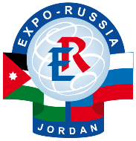 | XI INDUSTRIAL EXHIBITION  “EXPO-RUSSIA JORDAN 2013”  11 - 13 March 2013  Royal Convention Center Le Meridien Hotel.  Amman. Hashemite Kingdom of Jordan | 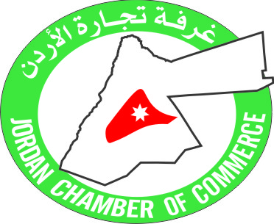
The exhibition is organized by «Zarubezh-Expo», Jordan Chamber of Commerce with the assistance of the International Association of Peace Foundations, of the Ministry of Economic Development of Russian Federation, the RF Ministry of Industry and Trade, Federal Agency for Affairs of the Commonwealth of Independent States, Nationals Residing Abroad and International Humanitarian Cooperation, the Russian Embassy in Jordan and the Jordanian Embassy in Russia, the Iraqi Embassy in Russia.
Under the Patronage of:
- Jordan Ministry of Industry and Trade
- Chamber of Commerce and Industry of Russian Federation

Thematic sections of the exhibition:

- Oil and Gas
- Geology
- Chemistry
- Medicine
- Education
- Agriculture
- Power
- Mechanical Engineering
- Metallurgy
- Construction
- Transport and Technical Equipment
- Telecommunications

The Business Program includes a economic conference on Russia –Middle East. In addition, 8th Russian-Jordanian Business Council, roundtable discussions will be organized in the Ministries of Jordan. This exhibition will provide its participants with a great opportunity to learn and promote their products, services, ideas and achievements locally in Jordan, regionally in the Middle East and internationally in the Russian Federation. As well as participate in direct Round Table discussions, to address and learn about a variety of topics and issues related to the Russian-Jordanian and Middle East Business Environment.
Director of Exhibition “EXPO-RUSSIA JORDAN” Svetlana Zabelina
Special price for Arabic companies 50USD per sq meter for equipped space (incl walls, fascia names, electicity, chirs, table.)

JSC «Zarubezh-Expo»
Prechistenka Str., 10, Moscow, Russia, 119034
+7(495) 637-50-79, 637-36-33, 721-32-36 +7 (499)766-99-17, 766-92-82
info@zarubezhexpo.ru, www.exporf.ru, www.zarubezhexpo.ru
mob +7-926-524-97-47

